|  |
| --- |
| Пензенский государственный университет  Факультет вычислительной техники  Кафедра «Вычислительная техника» |
| Отчет  по лабораторной работе №3  по дисциплине «Программирование на языке JAVA»  на тему «Обработка исключительных ситуаций»  Вариант № 2 |
|  |
|  |
| Выполнили: студенты группы 19ВВ3:  Субботкин М. В.  Ханбекова Е. В.  Проверила:  Юрова О. В. |
| Пенза  2022 |

**Цель работы:** изучить механизм обработки исключительных ситуаций.

**Задание на лабораторную работу**

Модифицировать приложение из предыдущей лабораторной работы, реализовав проверку вводимых данных с использованием механизма исключений. Необходимо создать свой класс, унаследованный от класса Exception, и генерировать исключение, если возникает попытка создать экземпляр класса RecIntegral со значениями, не являющимися числами в диапазоне от 0,000001 до 1000000. В качестве обработки исключения необходимо выводить диалог, содержащий предупреждение о некорректности введенных данных.

**Ход работы**

**Создание класса, унаследованного от класса Exception**

class MyExceptionClass extends Exception {

public MyExceptionClass(String message) {

super(message);

}

}

**Работа с Try, Catch**

try {

String sa = jTextField1.getText();

String sb = jTextField2.getText();

String sc = jTextField3.getText();

double a = Double.parseDouble(sa);

double b = Double.parseDouble(sb);

double c = Double.parseDouble(sc);

if (!sa.matches("[0-9]+")|!sb.matches("[0-9]+")|!sc.matches("[0-9]+")) {

throw new MyExceptionClass("Data is not correct");}

if (((0.000001 < a )&(a < 1000000))&((0.000001 < b )&(b < 1000000))&((0.000001 < c )&(c < 1000000))){

tblModel.addRow(new Object[]{jTextField1.getText(),jTextField2.getText(),jTextField3.getText()});

recIntegral.add(jTextField1.getText());

recIntegral.add(jTextField2.getText());

recIntegral.add(jTextField3.getText());

}

else {

throw new MyExceptionClass("Data is not correct");

}

} catch (MyExceptionClass e) {

JOptionPane.showMessageDialog(null, e);

}

**Листинг программы**

package labjava1;

import javax.swing.table.DefaultTableModel;

import java.util.LinkedList;

import javax.swing.JOptionPane;

public class labjava1UI extends javax.swing.JFrame {

public labjava1UI() {

initComponents();

}

@SuppressWarnings("unchecked")

// <editor-fold defaultstate="collapsed" desc="Generated Code">

private void initComponents() {

jButton5 = new javax.swing.JButton();

jButton3 = new javax.swing.JButton();

jButton2 = new javax.swing.JButton();

jButton1 = new javax.swing.JButton();

jScrollPane1 = new javax.swing.JScrollPane();

jTable1 = new javax.swing.JTable();

jLabel3 = new javax.swing.JLabel();

jTextField3 = new javax.swing.JTextField();

jLabel2 = new javax.swing.JLabel();

jTextField2 = new javax.swing.JTextField();

jLabel1 = new javax.swing.JLabel();

jTextField1 = new javax.swing.JTextField();

jButton4 = new javax.swing.JButton();

jButton6 = new javax.swing.JButton();

jButton7 = new javax.swing.JButton();

setDefaultCloseOperation(javax.swing.WindowConstants.EXIT_ON_CLOSE);

setMaximumSize(new java.awt.Dimension(21474836, 2147483647));

jButton5.setText("Exit");

jButton5.addActionListener(new java.awt.event.ActionListener() {

public void actionPerformed(java.awt.event.ActionEvent evt) {

jButton5ActionPerformed(evt);

}

});

jButton3.setText("Clk");

jButton3.addActionListener(new java.awt.event.ActionListener() {

public void actionPerformed(java.awt.event.ActionEvent evt) {

jButton3ActionPerformed(evt);

}

});

jButton2.setText("Delete");

jButton2.addActionListener(new java.awt.event.ActionListener() {

public void actionPerformed(java.awt.event.ActionEvent evt) {

jButton2ActionPerformed(evt);

}

});

jButton1.setText("Set");

jButton1.addActionListener(new java.awt.event.ActionListener() {

public void actionPerformed(java.awt.event.ActionEvent evt) {

jButton1ActionPerformed(evt);

}

});

jTable1.setModel(new javax.swing.table.DefaultTableModel(

new Object [][] {

},

new String [] {

"Lower border", "Upper border", "Step ", "Integral"

}

) {

boolean[] canEdit = new boolean [] {

false, false, false, false

};

public boolean isCellEditable(int rowIndex, int columnIndex) {

return canEdit [columnIndex];

}

});

jScrollPane1.setViewportView(jTable1);

jLabel3.setText("Step");

jLabel2.setText("Lower border");

jTextField2.addActionListener(new java.awt.event.ActionListener() {

public void actionPerformed(java.awt.event.ActionEvent evt) {

jTextField2ActionPerformed(evt);

}

});

jLabel1.setText("Upper border");

jTextField1.addActionListener(new java.awt.event.ActionListener() {

public void actionPerformed(java.awt.event.ActionEvent evt) {

jTextField1ActionPerformed(evt);

}

});

jButton4.setText("FILL");

jButton4.addActionListener(new java.awt.event.ActionListener() {

public void actionPerformed(java.awt.event.ActionEvent evt) {

jButton4ActionPerformed(evt);

}

});

jButton6.setText("CLEAR");

jButton6.addActionListener(new java.awt.event.ActionListener() {

public void actionPerformed(java.awt.event.ActionEvent evt) {

jButton6ActionPerformed(evt);

}

});

jButton7.setText("CLEAR TABLE");

jButton7.addActionListener(new java.awt.event.ActionListener() {

public void actionPerformed(java.awt.event.ActionEvent evt) {

jButton7ActionPerformed(evt);

}

});

javax.swing.GroupLayout layout = new javax.swing.GroupLayout(getContentPane());

getContentPane().setLayout(layout);

layout.setHorizontalGroup(

layout.createParallelGroup(javax.swing.GroupLayout.Alignment.LEADING)

.addGroup(javax.swing.GroupLayout.Alignment.TRAILING, layout.createSequentialGroup()

.addContainerGap(javax.swing.GroupLayout.DEFAULT_SIZE, Short.MAX_VALUE)

.addGroup(layout.createParallelGroup(javax.swing.GroupLayout.Alignment.TRAILING)

.addGroup(layout.createSequentialGroup()

.addGroup(layout.createParallelGroup(javax.swing.GroupLayout.Alignment.LEADING)

.addComponent(jLabel3)

.addComponent(jLabel1)

.addComponent(jLabel2))

.addGap(34, 34, 34)

.addGroup(layout.createParallelGroup(javax.swing.GroupLayout.Alignment.LEADING)

.addComponent(jTextField2, javax.swing.GroupLayout.PREFERRED_SIZE, 78, javax.swing.GroupLayout.PREFERRED_SIZE)

.addComponent(jTextField1, javax.swing.GroupLayout.PREFERRED_SIZE, 78, javax.swing.GroupLayout.PREFERRED_SIZE)

.addComponent(jTextField3, javax.swing.GroupLayout.PREFERRED_SIZE, 78, javax.swing.GroupLayout.PREFERRED_SIZE))

.addGap(61, 61, 61)

.addGroup(layout.createParallelGroup(javax.swing.GroupLayout.Alignment.LEADING)

.addGroup(layout.createSequentialGroup()

.addGap(72, 72, 72)

.addComponent(jButton1, javax.swing.GroupLayout.PREFERRED_SIZE, 65, javax.swing.GroupLayout.PREFERRED_SIZE)

.addPreferredGap(javax.swing.LayoutStyle.ComponentPlacement.UNRELATED)

.addComponent(jButton2)

.addGap(18, 18, 18)

.addComponent(jButton3, javax.swing.GroupLayout.PREFERRED_SIZE, 65, javax.swing.GroupLayout.PREFERRED_SIZE))

.addComponent(jButton5, javax.swing.GroupLayout.Alignment.TRAILING, javax.swing.GroupLayout.PREFERRED_SIZE, 60, javax.swing.GroupLayout.PREFERRED_SIZE)))

.addComponent(jScrollPane1, javax.swing.GroupLayout.PREFERRED_SIZE, 471, javax.swing.GroupLayout.PREFERRED_SIZE))

.addGap(184, 184, 184))

.addGroup(layout.createSequentialGroup()

.addGap(213, 213, 213)

.addComponent(jButton4, javax.swing.GroupLayout.PREFERRED_SIZE, 64, javax.swing.GroupLayout.PREFERRED_SIZE)

.addGap(18, 18, 18)

.addComponent(jButton6)

.addPreferredGap(javax.swing.LayoutStyle.ComponentPlacement.UNRELATED)

.addComponent(jButton7)

.addContainerGap(javax.swing.GroupLayout.DEFAULT_SIZE, Short.MAX_VALUE))

);

layout.setVerticalGroup(

layout.createParallelGroup(javax.swing.GroupLayout.Alignment.LEADING)

.addGroup(layout.createSequentialGroup()

.addGroup(layout.createParallelGroup(javax.swing.GroupLayout.Alignment.LEADING)

.addGroup(layout.createSequentialGroup()

.addGap(31, 31, 31)

.addGroup(layout.createParallelGroup(javax.swing.GroupLayout.Alignment.BASELINE)

.addComponent(jTextField1, javax.swing.GroupLayout.PREFERRED_SIZE, javax.swing.GroupLayout.DEFAULT_SIZE, javax.swing.GroupLayout.PREFERRED_SIZE)

.addComponent(jLabel2)))

.addGroup(layout.createSequentialGroup()

.addGap(39, 39, 39)

.addGroup(layout.createParallelGroup(javax.swing.GroupLayout.Alignment.BASELINE)

.addComponent(jButton1)

.addComponent(jButton2)

.addComponent(jButton3))))

.addPreferredGap(javax.swing.LayoutStyle.ComponentPlacement.RELATED)

.addGroup(layout.createParallelGroup(javax.swing.GroupLayout.Alignment.BASELINE)

.addComponent(jTextField2, javax.swing.GroupLayout.PREFERRED_SIZE, javax.swing.GroupLayout.DEFAULT_SIZE, javax.swing.GroupLayout.PREFERRED_SIZE)

.addComponent(jLabel1))

.addGap(18, 18, 18)

.addGroup(layout.createParallelGroup(javax.swing.GroupLayout.Alignment.BASELINE)

.addComponent(jLabel3)

.addComponent(jTextField3, javax.swing.GroupLayout.PREFERRED_SIZE, javax.swing.GroupLayout.DEFAULT_SIZE, javax.swing.GroupLayout.PREFERRED_SIZE)

.addComponent(jButton5))

.addGap(18, 18, 18)

.addComponent(jScrollPane1, javax.swing.GroupLayout.PREFERRED_SIZE, 102, javax.swing.GroupLayout.PREFERRED_SIZE)

.addGap(67, 67, 67)

.addGroup(layout.createParallelGroup(javax.swing.GroupLayout.Alignment.BASELINE)

.addComponent(jButton4)

.addComponent(jButton6)

.addComponent(jButton7))

.addContainerGap(158, Short.MAX_VALUE))

);

pack();

}// </editor-fold>

private void jButton5ActionPerformed(java.awt.event.ActionEvent evt) {

System.exit(0);

}

private void jButton3ActionPerformed(java.awt.event.ActionEvent evt) {

DefaultTableModel dt = (DefaultTableModel) jTable1.getModel();

double result = 0;

int row = jTable1.getSelectedRow();

if(row != -1){

String oa = jTable1.getValueAt(row,0).toString();

String ob = jTable1.getValueAt(row,1).toString();

String oh = jTable1.getValueAt(row,2).toString();

double a = Double.valueOf(oa);

double b = Double.valueOf(ob);

double h = Double.valueOf(oh);

double n = (b-a)/h;

for (int i = 0; i < n-1; i++){

result+= (Math.sin(a+i*h))*h;

}

result+= h*(Math.sin(a)+Math.sin(b))/2;

dt.setValueAt(result, row, 3);

}

}

LinkedList<Object> recIntegral = new LinkedList<>();

class MyExceptionClass extends Exception {

public MyExceptionClass(String message) {

super(message);

}

}

private void jButton1ActionPerformed(java.awt.event.ActionEvent evt) {

DefaultTableModel tblModel = (DefaultTableModel)jTable1.getModel();

try {

String sa = jTextField1.getText();

String sb = jTextField2.getText();

String sc = jTextField3.getText();

if (!sa.matches("[0-9]+")|!sb.matches("[0-9]+")|!sc.matches("[0-9]+")) {

throw new MyExceptionClass("Data is not correct");}

double a = Double.parseDouble(sa);

double b = Double.parseDouble(sb);

double c = Double.parseDouble(sc);

if (((0.000001 < a )&(a < 1000000))&((0.000001 < b )&(b < 1000000))&((0.000001 < c )&(c < 1000000))){

tblModel.addRow(new Object[]{jTextField1.getText(),jTextField2.getText(),jTextField3.getText()});

recIntegral.add(jTextField1.getText());

recIntegral.add(jTextField2.getText());

recIntegral.add(jTextField3.getText());

}

else {

throw new MyExceptionClass("Data is not correct");

}

} catch (MyExceptionClass e) {

JOptionPane.showMessageDialog(null, e);

}

jTextField1.setText("");

jTextField2.setText("");

jTextField3.setText("");

}

private void jButton2ActionPerformed(java.awt.event.ActionEvent evt) {

int row = jTable1.getSelectedRow();

int i=3;

while (i != 0 ){

recIntegral.remove(row*3);

i--;

}

DefaultTableModel tblModel = (DefaultTableModel)jTable1.getModel();

tblModel.removeRow(jTable1.getSelectedRow());

}

private void jTextField2ActionPerformed(java.awt.event.ActionEvent evt) {

// TODO add your handling code here:

}

private void jTextField1ActionPerformed(java.awt.event.ActionEvent evt) {

// TODO add your handling code here:

}

private void jButton4ActionPerformed(java.awt.event.ActionEvent evt) {

// TODO add your handling code here:

DefaultTableModel tblModel = (DefaultTableModel)jTable1.getModel();

for (int i = 0; i< recIntegral.size (); i+=3){

tblModel.addRow(new Object[]{recIntegral.get(i),recIntegral.get(i+1),recIntegral.get(i+2)});

}

}

private void jButton6ActionPerformed(java.awt.event.ActionEvent evt) {

// TODO add your handling code here:

recIntegral.clear();

}

private void jButton7ActionPerformed(java.awt.event.ActionEvent evt) {

// TODO add your handling code here:

DefaultTableModel tblModel = (DefaultTableModel)jTable1.getModel();

while(tblModel.getRowCount() != 0){

tblModel.removeRow(0);

}

}

/**

* @param args the command line arguments

*/

public static void main(String args[]) {

/* Set the Nimbus look and feel */

//<editor-fold defaultstate="collapsed" desc=" Look and feel setting code (optional) ">

/* If Nimbus (introduced in Java SE 6) is not available, stay with the default look and feel.

* For details see http://download.oracle.com/javase/tutorial/uiswing/lookandfeel/plaf.html

*/

try {

for (javax.swing.UIManager.LookAndFeelInfo info : javax.swing.UIManager.getInstalledLookAndFeels()) {

if ("Nimbus".equals(info.getName())) {

javax.swing.UIManager.setLookAndFeel(info.getClassName());

break;

}

}

} catch (ClassNotFoundException ex) {

java.util.logging.Logger.getLogger(labjava1UI.class.getName()).log(java.util.logging.Level.SEVERE, null, ex);

} catch (InstantiationException ex) {

java.util.logging.Logger.getLogger(labjava1UI.class.getName()).log(java.util.logging.Level.SEVERE, null, ex);

} catch (IllegalAccessException ex) {

java.util.logging.Logger.getLogger(labjava1UI.class.getName()).log(java.util.logging.Level.SEVERE, null, ex);

} catch (javax.swing.UnsupportedLookAndFeelException ex) {

java.util.logging.Logger.getLogger(labjava1UI.class.getName()).log(java.util.logging.Level.SEVERE, null, ex);

}

//</editor-fold>

/* Create and display the form */

java.awt.EventQueue.invokeLater(new Runnable() {

public void run() {

new labjava1UI().setVisible(true);

}

});

}

// Variables declaration - do not modify

private javax.swing.JButton jButton1;

private javax.swing.JButton jButton2;

private javax.swing.JButton jButton3;

private javax.swing.JButton jButton4;

private javax.swing.JButton jButton5;

private javax.swing.JButton jButton6;

private javax.swing.JButton jButton7;

private javax.swing.JLabel jLabel1;

private javax.swing.JLabel jLabel2;

private javax.swing.JLabel jLabel3;

private javax.swing.JScrollPane jScrollPane1;

private javax.swing.JTable jTable1;

private javax.swing.JTextField jTextField1;

private javax.swing.JTextField jTextField2;

private javax.swing.JTextField jTextField3;

// End of variables declaration

}

**Результат работы программы**

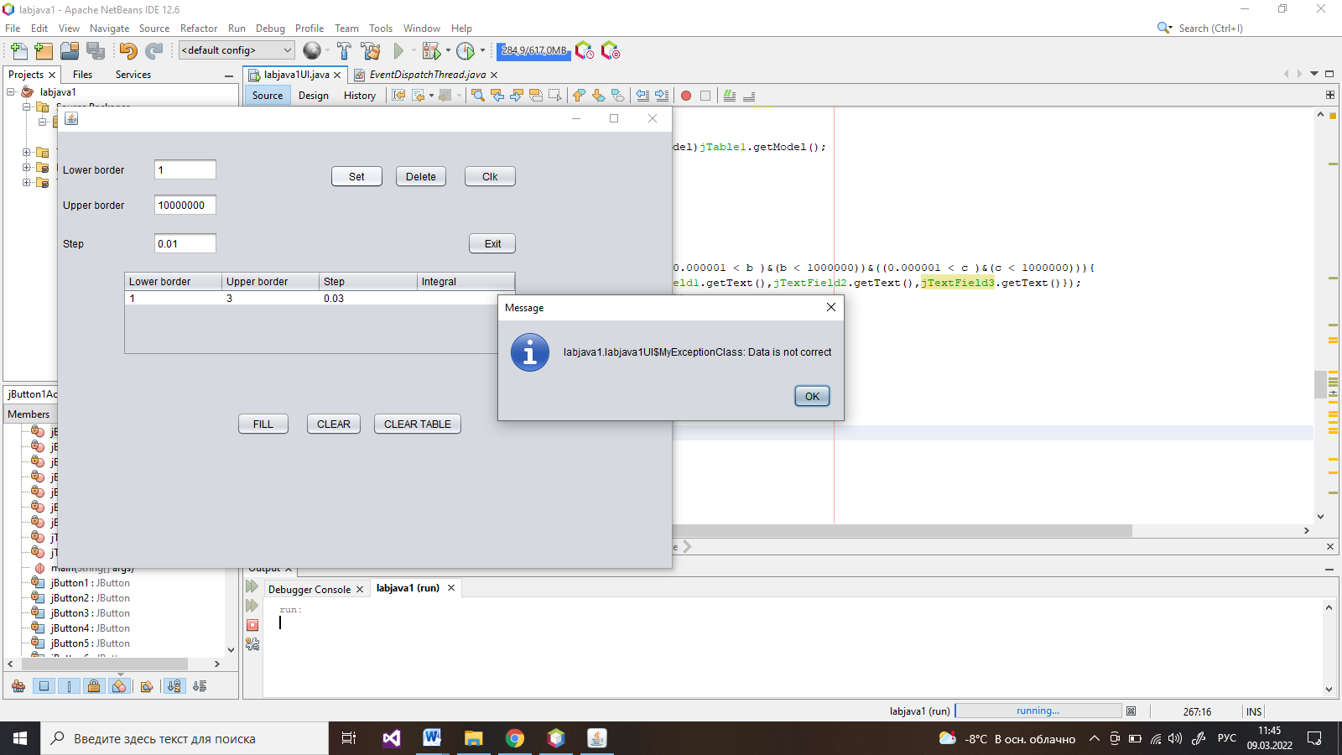

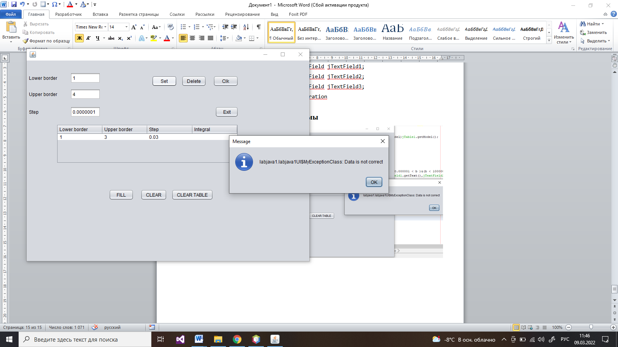

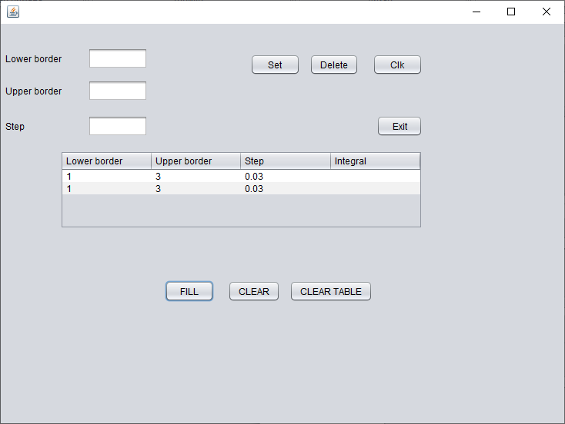

**Вывод**

В ходе работы познакомились с обработкой исключений на JAVA. Модифицировали приложение из предыдущей лабораторной работы, реализовав проверку вводимых данных.